**GROUP 7 WORK**

**REPORT ON THE DIAGNOSIS OF THE POWER SUPPLY (**LiteOn PS-5181-02 VG)

MEMBERS

1. DAVID ABUGA - BTCES/2022/51488

2. ALEX SAIBULU - BTCES/2022/71271

3. LINET KAMAU -BTCES/2021/96325

4. Emmanuel wekesa btces/2022/57519

**Key Specifications:**

* Model: PS-5181-02 VG
* AC Input Voltage: 100-127V / 200-240V ~ (Dual input range)
* AC Input Frequency: 50-60Hz

DC Output Voltages:

* +12V (main) @ 14A (168W)
* +12V (orange) @ 1A (12W)
* +3.3V @ 3A (9.9W)
* +5Vsb (standby) @ 3A (15W)

Power Output Rating: 180W max

**Objectives of the ATX Power Supply** LiteOn PS-5181-02 VG)

1. **Efficient Power Conversion**:
2. **Multiple Output Voltage Rails**:
   * Provide stable and regulated DC voltage rails (+12V, +5V, +3.3V) for various electronic components in a computer or electronic system.
3. **High-Frequency Switching**:
   * We use high-frequency switching to reduce the size of the transformer and associated components, thereby minimizing the overall size of the power supply without sacrificing performance.
4. **Isolation Between Primary and Secondary Circuits**:
   * electrical isolation between the high-voltage AC primary side and the low-voltage DC secondary side using a transformer, promoting safety and preventing high-voltage feedback.
5. **Regulation and Stability**:
   * Maintain output voltage stability under varying load conditions through a closed-loop feedback system

**SCHEMATIC DIAGRAM OF THE POWER SUPPLY**

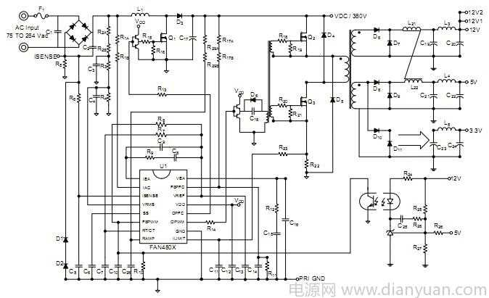

**EXPLA NATION OF THE SCHEMATIC DIAGRAM**

**Primary Side:**

* **AC Input:** This is where the mains power is fed into the power supply. The AC input is specified at 100-127V or 200-240V with current ratings of 5A or 2.5A respectively. The primary side handles converting AC to DC, which is the job of components like the rectifier, PFC (Power Factor Correction) circuitry, and primary switching transistors or MOSFETs.
* • **PWM Controller (U1 - FAN4803)**: The heart of the SMPS is the **Pulse Width Modulation (PWM) controller**, here identified as **U1 (FAN4803)**. The PWM controller regulates the switching transistors' operation by adjusting the pulse width of the switching signal, thus controlling the power transferred to the transformer.
* • **Switching Transistors (Q1)**: The transistors act as high-speed switches, alternating the DC voltage at high frequencies (typically in the range of 50kHz to 100kHz). These switches work in synchronization with the PWM controller. The high-frequency switching significantly improves the power supply's efficiency and allows for smaller transformers and filter components.

**Secondary Side:**

* **DC Output:** This side produces multiple voltage rails (+3.3V, +5V, +12V, -12V, +5Vsb), and each voltage corresponds to different color-coded wires. The components on this side include diodes, filters (inductors, capacitors), and regulators to ensure stable DC output.

**Components on the Primary Side:**

1. **Input Rectifier Diodes** – These convert the AC mains voltage to DC.
2. **Input Filter Capacitors** – These capacitors smooth out the rectified DC voltage.
3. **PFC Circuitry** – Power Factor Correction helps in reducing the reactive power in the system.
4. **Primary Switching Transistors or MOSFETs** – These switch the DC voltage at high frequency, which is the key to regulating the output.
5. **Transformer** – This is a key component that steps down the high-frequency AC voltage created by the switching transistors for the secondary side.

**Primary Side Circuit:**

1. **AC Input (240V AC)**
2. **Fuse** – For protection.
3. **EMI Filter** – Inductors and capacitors to suppress noise.
4. **Bridge Rectifier** – Converts AC to DC.
5. **Large Filter Capacitor** – Smooths out the DC from the rectifier.
6. **Power Factor Correction (PFC) Circuit** – Optional in some designs but helps improve efficiency.
7. **Switching Transistor or MOSFET** – Controls the current to the transformer.
8. **Transformer** – Isolates and steps down the voltage for the secondary side.

**Visual Inspection**

Casing: No physical damage, clean fan vents.

Connectors: All connectors in good condition

Capacitors: No swelling or leaks observed.

**MISSING COMPONENTS**

ZENER DIODE MISSING ON THE BOARD

OUTPUT ATX WIRES MISSING

**BURNS**

DC TO DC HIGH POWER CONTROLLER

**VOLTAGE AT THE OUTPUT**

| **Pin** | **Wire Color** | **Function** | **Voltage** |
| --- | --- | --- | --- |
| 1 | Orange | +3.3V | 3.3V |
| 2 | Orange | +3.3V | 3.3V |
| 4 | Red | +5V | 5V |
| 8 | Grey | Power Good | 5V |
| 9 | Purple | +5V Standby | 5Vsb |
| 10 | Yellow | +12V | 12V |
| 12 | Yellow | +12V | 12V |
| 13 | Orange | +3.3V | 3.3V |
| 14 | Blue | -12V | -12V |
| 16 | Green | PS_ON | - |
| 17-24 | Black | Ground | 0V |

HIGH – VOLTAGE DC BUS

* High voltage capacitors
* Voltage sesing resistors

RECTIFIER AND POWER FACTOR

* Bridge rectifier diodes
* Pfc controllers
* Capacitors and inductors

AC INPUT STAGE

* Input terminals
* Fuse
* Inrush current limiter
* Emi filter

OPTO COUPLER SWITCH

**PWM CONTROLLER AND SWITCHING STAGE**

* **FAN4803**
* **MOSFETS**

**TRANSFORMER**

* **STEP DOWN**
* **SOLATE PRIMARY FROM SECONDARY**

**STANDBY POWER SUPPLY**

**+5 VOLTAGE**

**SECONDARY RECTIFICATION AND FILTERING**

* **DIODES**
* **CAPACITORS**
* **INDUCTORS**

OUTPUT VOLTAGE REGULATION

* OPTOCOUPLER
* VOLTAGE SENSING RESISTORS
* OUTPUT VOLTAGES +12V, +5V, +3.3V

WORK ON PROTEOUS

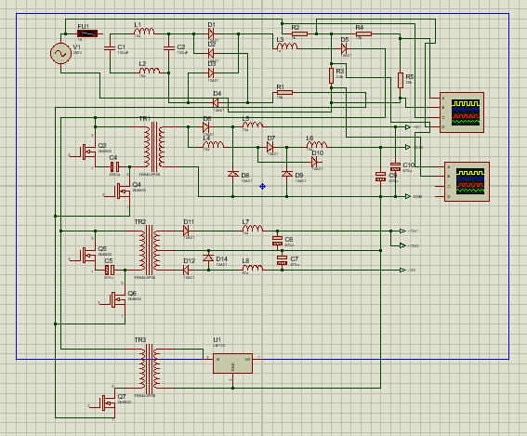

* This circuit takes an AC input, filters it, rectifies it to DC, protects against overcurrent conditions, and stabilizes the output with MOSFETs and filtering capacitors.

1. **Input Stage (AC Source)**

* AC Supply: The circuit starts with an AC voltage source, represented by the fuse (F1) and potentially a transformer.
* Transformer: Three transformers (TR1, TR2, TR3) are included, which step down or step up the AC voltage depending on the system's requirements.

1. **Rectification Stage**

* Diodes: Full-wave rectification is achieved using diode bridges (D1–D4). These convert the AC voltage from the transformer into pulsating DC voltage.
* Capacitors (e.g., C1, C2): These are filter capacitors, smoothing out the pulsating DC voltage to reduce ripples.

1. **Filtering and Regulation**

* Inductors (L1, L2): These serve as filters to remove high-frequency noise from the power supply.
* Voltage Regulator IC (U1): The IC (likely a linear voltage regulator such as 7805, 7812, or similar) provides a stable DC output voltage by regulating the fluctuating input.

1. **Protection Circuitry**

* Fuses and Resistors: These provide overcurrent and surge protection for the circuit.
* Zener Diodes (e.g., D5): These may be used for overvoltage protection or as voltage references.

**OUTPUT WAVES**

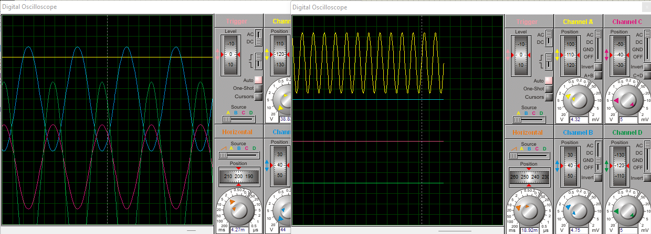

**On left oscilloscope**

* This is the unaltered AC input voltage.
* The sine wave indicates an alternating voltage supply with peaks in both positive and negative polarities.
* The overlay of sine waves might represent multiple AC signals feeding different rectification sections.

**On the right oscilloscope**

* This is the output after filtering and regulation.
* Filter capacitors remove the high-frequency ripples, and the voltage regulator ensures a stable, constant DC voltage output.
* The clean output confirms the circuit is functioning correctly in this stage.

**Yellow Curve**: Represents the smoothed and regulated DC output voltage. The almost constant value indicates effective filtering and regulation with minimal ripple.